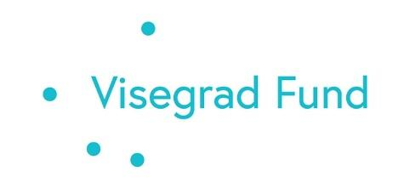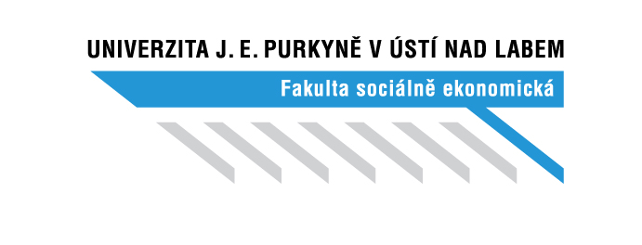

**Invitation to Workshop: Sustainable Population Consumption in a Post-Pandemic Economy. The Perspective of Three Countries**

Dear Ladies and Gentlemen,

We cordially invite you to a two-day workshop organised by the Faculty of Social and Economic Studies of Jan Evangelista Purkyně University in Ústí nad Labem as part of the project “Sustainable Population Consumption in a Post-Pandemic Economy. The Perspective of Three Countries.” The workshop will take place on 9-10 October 2024, in Ústí nad Labem, FSE UJEP, Moskevská 54, „Vysokoškolský klub“, 4th floor.

**Programme:**

**9 October 2024 (Wednesday)**

* 13:30 - 14:00 - Registration of participants
* 14:00 - 14:15 - Welcome and introduction (Ing. Michaela Jánská, PhD. – main organiser of the workshop)
* 14:15 - 15:00 “*Cost-Benefit Analysis (CBA) as a tool to promote the*
* *development of more sustainable and resilient cities“ (Ing. Jan Macháč, Ph.D.*
* *FSE and guest from IREAS)*
* 15:00 - 15:45 – *„Presentation of CzechInvest activities“* (Ing. Petra Vaculíková - Director of the CzechInvest Regional Office)
* 15:45 - 16:00 - Coffee break
* 16:00 - 16:45 – “*Sustainable consumption in three countries - Czech Republic, Slovakia and Poland"* (doc. RNDr. Marta Žambochová Ph.D., prof. Ing. Pavol Kita PhD. and Dr hab. Prof. Grzegorz Maciejewski)
* 17:00 - 18:00 - Discussion

**10 October 2024 (Thursday)**

* 9:00 - 9:45 – *"Pro-ecological consumer behaviour. Empirical evidence from*
* *Poland"* (Dr hab. prof. Grzegorz Maciejewski, University of Economics
* in Katowice, Poland)
* 9:45 - 10:30 -*"Schicht - the rebirth of the Jelen brand and its current challenges"*, (Ing. Libor Duba - Managing Director of Schicht)
* 10:30 - 11:00 - Coffee break
* 11:00 - 11:45 - *"Characteristics of retail and the retail business model in the context of sustainable consumption"* (Prof. Ing. Pavol Kita PhD., Comenius University in Bratislava, Slovak Republic)
* 11:45 - 12:30 – *„B2B companies' approach to ESG issues and their preparation for non-financial reporting"* (Ing. Martina Weberová - B2B marketing expert)
* 12:30 - 13:30 - Closing of the event and lunch

Please reserve this date in your diary and confirm your attendance by emailing hana.galiova@ujep.cz by 4 October 2024. It is possible to attend the whole event or a selected day.

We look forward to your participation!

The workshop is part of the project "Sustainable Population Consumption in a Post-Pandemic Economy. The Perspective of Three Countries," project number 22320074, supported by the Visegrad Grant. Project implementation period: 11/2023 – 4/2025.