ACQUAINTANCE OF STUDENTS
with information and instructions to ensure safety and health at work and fire protection at UJEP in Ústí nad Labem and all its workplaces.
INFORMATION AND INSTRUKTIONS FOR MOVEMENT AND BEHAVIOR ON THE OBJECT
I. Introduction:
The employer's obligation to ensure safety and health at work applies to all-natural persons who, with his knowledge, stay at his workplaces in accordance with § 101, Section 5 of the Labor Code. This obligation also applies to the care for the protection of students' health during and in direct connection with teaching, at all workplaces and in all facilities of the university.
Ensuring safety and health protection at work (hereinafter referred to as OSH) is one of the prerequisites for the proper performance of educational and training functions of UJEP.

II. Basic instructions on risks and safe behaviour:
- Basic information on risks:
External roads and parking areas - collisions with vehicles, falling objects (various materials) from a height, slipping, tripping, falling; internal communications, corridors, floors, stairs - slipping, tripping, falling, possible falling objects from a height, from a wall, etc .; moving parts of machines, transported and stored material, falling objects and furniture, harmful chemical substances - impact; doors, windows, doors and drawers of furniture - hitting, pinching, hitting sharp edges; chairs, elevated workplaces, depressions - falling from a height or into a depth; glass, sharp edges (machines, aids, shards) - cutting; hot surfaces, liquids - burns, scalds; electrical equipment - electric shock current, gas equipment - gas leak, explosion; elevators - a fall into an elevator shaft that is not closed due to a fault.

- Basic OSH lessons
- In the interest of protecting, one's own health and the health of other persons, the student is especially obliged to:
- behave in such a way as not to endanger the health of themselves and others,
- comply with all safety regulations with which he was acquainted through the teacher (or head of the workplace),
- observe the principles of safe behaviour in the common areas of UJEP, in classrooms, laboratories, workshops, corridors, staircases, canteens, etc.,
- undergo a knowledge test within the scope of the regulation or activity, if required by the safety regulation or justified by the risk of the activity,
- report to the pedagogical supervision defects and deficiencies of the workplace that could endanger safe work,
- immediately report to the pedagogical worker (head of the workplace) any injury that occurred during the performance of school duties or in direct connection with them, fire or other serious incidents.
- do not drink alcohol before and during classes, do not abuse other narcotics, do not smoke in areas where smoking is prohibited.
- The student may not manipulate, switch on, switch off, or operate any machines, devices and equipment that were not assigned to him within the teaching and with the operation of which he was not familiar.
The student is also obliged to:
- Use only designated paths, roads, entrances, entrances, exits, exits for walking and driving, do not enter other particularly dangerous areas. To walk, use the sidewalks, or the left side of the road, in pairs at most. Beware of wet, icy roads.
- On the access and external roads in the UJEP premises, the "Rules of Road Traffic" apply to pedestrians and all means of transport.
- Loading and unloading of vehicles can only be done in designated areas. - Always walk to the right in the corridors of UJEP buildings, stairs, workplaces, and other areas, do not run, do not jump, do not ride on the handrail, do not lean out of the windows, prevent accidents.
- Respect all restrictions and prohibitions. Do not touch power lines and equipment.
- Maintain order and cleanliness in hallways, classrooms, and other rooms.
- First aid kits are in places marked with a green cross, especially in receptions (gatehouses), etc.
- Emergency evacuation routes are marked with green markers with white pictograms of the direction of escape.
- In case of an emergency, call the phone numbers:
112 - SOS Integrated Rescue System, 155 - Rescue Service,
150 - fire brigade,
158 - police of the Czech Republic.
- Instructions and information for securing fire safety, fighting fires and other emergencies

- Everyone is obliged to act in such a way that he does not cause a fire.
- Anyone who notices a fire that cannot extinguish themselves is obliged to immediately sound the alarm by calling BURNING, in some buildings with electric fire alarm buttons, and report the fire at the reception (gatehouse) of the building, and the public fire station of the Fire and Rescue Service of the Ústí Region. they could intervene as soon as possible
- to tell WHO is calling, WHERE and WHAT is on fire, or what an emergency
- has occurred, wait for the call-back.
- If possible, start fire extinguishing immediately, or provide material assistance, take the necessary measures to rescue endangered persons.
- Everyone is obliged to maintain free escape routes and exits, access to manual fire extinguishers, fire water mains, main power switches. energy, water, and gas closures; do not stop them with various materials, etc.
- Know the location and use of hand fire extinguishers, or other fire extinguishers located in the workplace.
- Detected fire defects, report to the head of the workplace or reception, and, if necessary, according to their opportunities to actively participate in their removal.
Instructions on the use of portable fire extinguishers located in the corridors in the individual floors of the buildings and in other areas of UJEP:
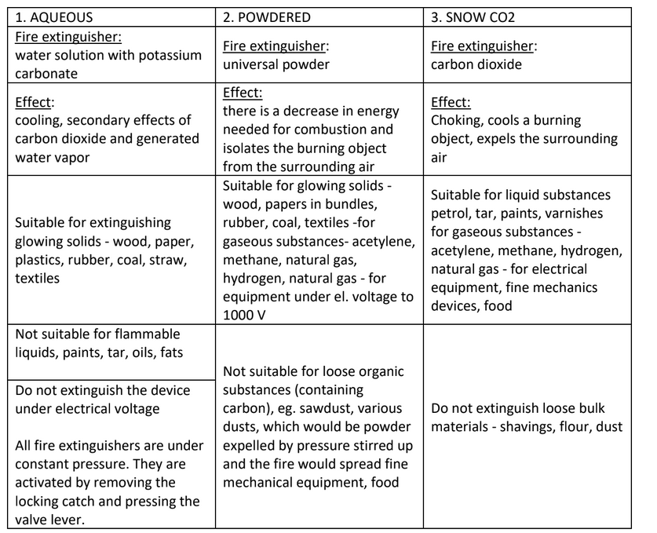

All fire extinguishers are under constant pressure. They are activated by removing the locking lock and are immediately functional when the valve lever is pressed.
Considering the different need for professional knowledge, students will be further informed about safety regulations and fire protection regulations according to specific conditions at individual workplaces of practical training - in workshops, laboratories, studios, sports, and other equipment.

STUDENT STATEMENT
I declare that I have read the information and instructions for ensuring safety and health at work and fire protection at UJEP in Ústí nad Labem at all its workplaces. Information is available on the UJEP website (www.ujep.cz) under the link Official Board. I have read the information, understood its content, and undertake to follow the instructions.
Ústí nad Labem, Date: __________________________________
Name and surname of the student: __________________________________
Student's signature: __________________________________

